Questions:

- What is Deep Learning?
- What are the differences between Machine Learning and Deep Learning?
- What advantages does Deep Learning have over Machine Learning?
- What is Artificial Neural Network?
- Explain the Architecture of Neural network?
- What is Perceptron?
- Explain the work of Perceptron.
- Define Activation Function?

Is ANN similar to standard computers? Explain?
- What is back propagation?

Answers:

- Deep learning is a subset of machine learning, which is essentially a neural network with three or more layers. These neural networks attempt to simulate the behaviour of the human brain allowing it to “learn” from large amounts of data. While a neural network with a single layer can still make approximate predictions, additional hidden layers can help to optimize and refine for accuracy.
Deep learning drives many AI applications and services that improve automation, performing analytical and physical tasks without human intervention. Deep learning technology lies behind everyday products and services (such as digital assistants, voice-enabled TV remotes, and credit card fraud detection) as well as emerging technologies (such as self-driving cars).

- The difference between Machine Learning and Deep Learning:
S.No. | Machine Learning | Deep Learning
1. | Machine Learning is a superset of Deep Learning | Deep Learning is a subset of Machine Learning
2. | The data represented in Machine Learning is quite different as compared to Deep Learning as it uses structured data | The data representation is used in Deep Learning is quite different as it uses neural networks(ANN).
3. | Machine Learning is an evolution of AI | Deep Learning is an evolution to Machine Learning. Basically it is how deep is the machine learning.
4. | Machine learning consists of thousands of data points. | Big Data: Millions of data points.
5. | Outputs: Numerical Value, like classification of score | Anything from numerical values to free-form elements, such as free text and sound.
6. | Uses various types of automated algorithms that turn to model functions and predict future action from data. | Uses neural network that passes data through processing layers to the interpret data features and relations.
7. | Algorithms are detected by data analysts to examine specific variables in data sets. | Algorithms are largely self-depicted on data analysis once they’re put into production.
8. | Machine Learning is highly used to stay in the competition and learn new things. | Deep Learning solves complex mac

3. Advantages of Deep Learning
- It gives a better performance compared to machine learning if the dataset is large enough.
- It does not need the person designing the model to have a lot of domains understanding for feature introspection. Deep learning outshines other methods if there is no feature engineering done.
- Deep Learning really shines when it comes to complex problems such as image classification, natural language processing, and speech recognition.

- The term "Artificial Neural Network" is derived from Biological neural networks that develop the structure of a human brain. Similar to the human brain that has neurons interconnected to one another, artificial neural networks also have neurons that are interconnected to one another in various layers of the networks. These neurons are known as nodes.
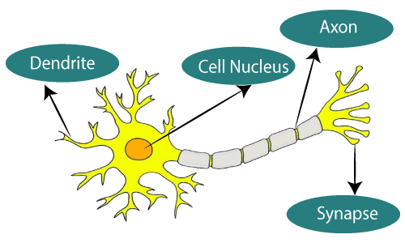
The given figure illustrates the typical diagram of Biological Neural Network.
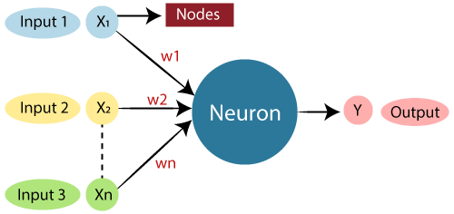

The typical Artificial Neural Network looks something like the given figure.
Dendrites from Biological Neural Network represent inputs in Artificial Neural Networks, cell nucleus represents Nodes, synapse represents Weights, and Axon represents Output.

ANNs consist of artificial neurons. Each artificial neuron has a processing node (‘body’) represented by circles in the figure as well as connections from (‘dendrites’) and connections to (‘axons’) other neurons which are represented as arrows in the figure. In a commonly used ANN architecture, the multilayer perceptron, the neurons are arranged in layers.
Artificial Neural Network primarily consists of three layers:
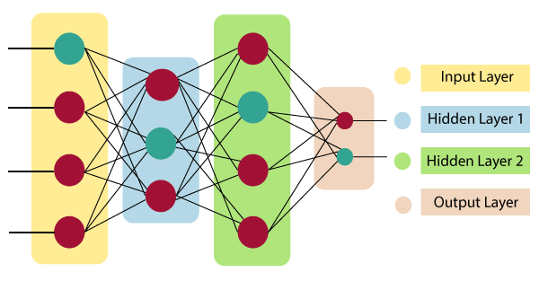
Input Layer:
As the name suggests, it accepts inputs in several different formats provided by the programmer.
Hidden Layer:
The hidden layer presents in-between input and output layers. It performs all the calculations to find hidden features and patterns.
Output Layer:
The input goes through a series of transformations using the hidden layer, which finally results in output that is conveyed using this layer.

- A perceptron also called an artificial neuron is a neural network unit that does certain computations to detect features.
It is a single-layer neural network used as a linear classifier while working with a set of input data. Since perceptron uses classified data points which are already labeled, it is a supervised learning algorithm. This algorithm is used to enable neurons to learn and process elements in the training set one at a time. A perceptron is the simplest form of a neural network which is used as an algorithm or a linear classifier to facilitate supervised learning of binary classifiers.
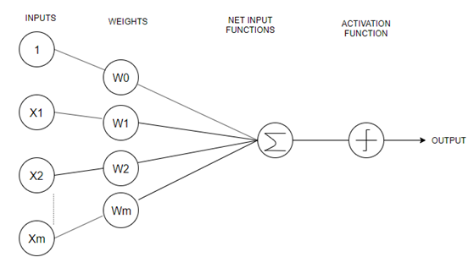

- Steps to perform a perceptron learning algorithm
- Feed the features of the model that is required to be trained as input in the first layer.
- All weights and inputs will be multiplied – the multiplied result of each weight and input will be added up
- The Bias value will be added to shift the output function
- This value will be presented to the activation function (the type of activation function will depend on the need)
- The value received after the last step is the output value.

- Choosing a good loss function definition plays a pivotal role in the quality of the final model. For every task in deep learning, there are several loss functions which can result in different models.
There is no universal loss function which is suitable for all machine learning model. Depending upon the type of problem statement and model, a suitable loss function needs to be selected from the set of available. Different parameters like type of machine learning algorithm, degrees of the percentage of outliers in the provided dataset, ease of calculating derivatives etc. play their role in choosing loss function. Gradually, with the help of some optimization function, loss function learns to reduce the error in prediction.

- To perform a task by a machine, a neural network must have active neurons. The activation function is used to decide whether a neuron is active or not. For this purpose, Activation Function calculates a weighted sum and further adding bias with it. Activation function's main task is to introduce non-linearity into the output of a neuron. The activation function in the mathematical form is given below:
net-input = ? (weight*input) + bias
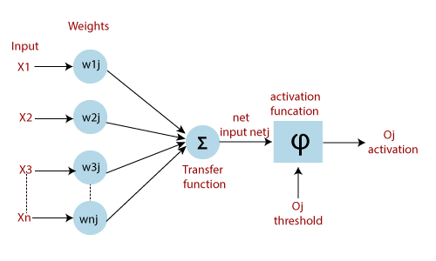

- Artificial Neural Network is not similar to standard computers. The difference is that an artificial neural network is learned by example and performs its task, but standard computer performs their jobs which are based on algorithms. Standard computer learns nothing, but they work according to the algorithm.

- The backpropagation algorithm is used to train multilayer perceptrons. It propagates the error information from the end of the network to all the weights inside the network. It allows the efficient computation of the gradient or derivatives.
Backpropagation can be divided into the following steps:
- It can forward the propagation of training data through the network to generate output.
- It uses target value and output value to compute error derivatives by concerning the output activations.
- It can backpropagate to calculate the derivatives of the error concerning output activations in the previous layer and continue for all the hidden layers.
- It uses the previously computed derivatives for output and all hidden layers to calculate the error derivative concerning weights.
- It updates the weights and repeats until the cost function is minimized.

